SensitviT Sensors Inc.

February 21, 2019

Mykola Matukhno, Charlie Nitschelm  
SensitiviT Sensors  
Quality Control  
HotTimes, YS 66666  
  
Dear Urfirst Boss,

As requested, this report details the information asked from our face-to-face meeting and follow-up email to investigate the various methods used for calculating the time constant, τ.

During the last two weeks, Mykola and I have experimented with our various thermocouples and thermistors to review the calculation of our sensors time constants in water and air. We have also considered the impact of the time in air during the transition between the baths to provide a more reliable database of temperature vs. time. A more reliable fit of the data was also introduced using 0.2 < Γ < 0.7 to obtain better accuracy of the data fit, which will be explained in this report. Once the fit had been determined, quantitative methods were utilized to provide residuals and of the fit to the actual data to evaluate the accuracy of the new fit methods. We also go in depth on the experimental methods used during the data collection involving two constant temperature baths, temperature sensors, and the methods used for their analysis. Lastly, our results are shown with our recommendation on how to move forward with more reliable, constant thermocouple and thermistor specifications for our consumers.

If there are any questions, do not hesitate to contact us,

Mykola Matukhno – [mm1536@wildcats.unh.edu](mailto:mm1536@wildcats.unh.edu)

Charlie Nitschelm – [cjn1012@wildcats.unh.edu](mailto:cjn1012@wildcats.unh.edu)

# Static and Dynamic Characteristics of Measurement Systems

Written and Analyzed By: Mykola Matukhno and Charlie Nitschelm

SensitiviT Industries Ltd

February 21st, 2019

Table of Contents

Static and Dynamic Characteristics of Measurement Systems 2

Table of Figures 3

Executive Summary 5

Introduction 6

Experimental Methods 8

Experimental Results and Discussion 12

Summary and Conclusions 16

# Table of Figures

Figure 1 - Calculated fits of a steel-insulated thermocouples transition from ice water to boiling water using different Gamma range fits with calculated time constants and standard error of fit. 6

Figure 2 - Relating temperature versus time of a bare thermocouple from ice water to boiling water. Notice the calculate final temperature used for the Gamma calculation above. 7

Figure 3 - Data collection setup for static calibration and measurements 8

Figure 4 - Data collection setup for dynamic measurements using a DAQ 9

Figure 5 - Relating temperature versus time of a bare thermocouple from ice water to boiling water. Notice the calculate final temperature used for the Gamma calculation above. 10

Figure 6 - The natural log of Gamma plotted with time for a bare thermocouple transition from ice water to boiling. Notice the increase scatter of Gamma as the thermocouple approaches steady state condition. 11

Figure 7 - A bare thermocouple transition from ice water to boiling water with appropriate estimated fits of the data utilizing different Gamma ranges. Notice the difference in accuracy of the two Gamma fits. 12

Figure 8 - A steel-insulated thermocouple's Gamma transition data from ice water to boiling with calculated time constants for different Gamma fits. Notice the different fits depending on what Gamma range was used. 12

Figure 9 - Calculated fits of a bare thermocouples transition from ice water to boiling water using different Gamma range fits with calculated time constants and standard error of fit. Notice the accuracy difference between the two Gamma fits. 13

Figure 10 - Calculated fits of a steel-insulated thermocouples transition from ice water to boiling water using different Gamma range fits with calculated time constants and standard error of fit. Notice the accuracy difference between the two Gamma fits. 13

Figure 11 - The residuals of the bare thermocouple transition from ice water to boiling water comparing the accuracy of the two different Gamma fits. Notice how the 0.2 to 0.7 Gamma fit is far more accurate during the beginning of the test. 14

Figure 12 - The residuals of the steel-insulated thermocouple transition from ice water to boiling water comparing the accuracy of the two different Gamma fits. Notice how the 0.2 to 0.7 Gamma fit is far more accurate during the beginning of the test. 14

Figure 13 – Table of primary parameters of our thermocouple with the analysis of using different Gamma fits 15

Figure 14 - Calibration curve using the thermistor temperature and voltage of the thermocouple 17

Figure 15 - Confidence limits of the calibration curve to illustrate a 95% confidence based on the actual data and the fit 18

Figure 16 - A confidence interval graph comparing both Gamma ranges for a bare thermocouple going from ice water to boiling water 19

Figure 17 - A confidence interval graph comparing both Gamma ranges for a steel-insulated thermocouple going from ice water to boiling water 19

Figure 18 - The fractional uncertainy of the determination of the time constant plotted against calculated Gamma values. Notice the uncertainty near 0 and 1, inspiring the new Gamma fit using 0.2-0.7. 20

Executive Summary

The root of our investigation was to evaluate the different methods of determining 𝜏, the time constant, for J-Type thermocouples. To do so, we needed to determine the static sensitivity and the according uncertainty of our results. There were three thermocouples used during the investigation: bare thermocouples, and two embedded thermocouple made of 6061 aluminum and 304 stainless steel.

We used two different methods to determine the start of the dynamic analysis. The first method was to determine the steepest slope of the transition between to temperature baths. This would be the point at which the thermistor was placed into the new temperature bath utilizing a shifting linear fit. The second method utilized and once the first data point to fall outside of five times would then be considered the start for

The study consisted of two major section, in which this report will go into much detail: data collection and then analysis. The data collection section began with the recording of temperatures of a thermocouple against a thermistor at different known temperatures. β and , the constants for a thermistor, needed to be calculated for temperatures for boiling water and ice water. With the constants solved, a clear relationship between voltage output and real-time temperature could be developed and trusted. With the thermocouple and thermistor taped together, we could ensure that they would experience the same temperature environment, allowing us to coordinate the data from the thermistor to solve for the thermocouple temperature output. Ten separate data points were recorded for this exact purpose. We used a fixed ice bath assumed to be at exactly 0°C to obtain reliable and averaged results on this temperature point. It also lets us obtain the static sensitivity of the thermocouples by performing a statistical analysis on the data.

A more reliable fit of the data was also introduced using 0.2 < Γ < 0.7 with the original 0 < Γ < 1. With the application of using residuals and standard error of the fit, it was clear the new gamma fit produced less residuals, leading to a more fitting fit of the thermocouple data. The clear results of this can be seen in Figure 6, Figure 7, Figure 8, and Figure 9.

Introduction

We investigated different methods for producing numerical models of both bare and insulated thermocouple. These models produced can assist in predicting the response of these devices when subjected to various temperatures. With the equation that attempts to fit the data, real-time residuals can now be calculated to help determine how accurate the equation is to real experimental data. This analysis assisted us in determining the most accurate model and in more importantly, what modeled produces that accurate prediction.

The equipment used to obtain the data needed for this analysis needs to assume a first order measurement system response with a step change in input. The response of this assumption allows us to create models and more importantly, equations, to model the data obtained from the thermocouples and the thermistors. When a thermocouple transitions from a particular temperature bath to another, there is a non-negotiable period of time the thermocouple will experience in the air. Figure 1 details this concept and Figure 2 illustrates the calculated numbers for the initial and final temperatures. This must be dealt with within the analysis when calculating what the should be in order to not interfere with the error of time in the air and correlates to the max slope, or greatest change in temperature with respect to time. That can be then set to so the analysis can continue with the start of what is being analyzed (). Work has also been done concerning the time where the temperature has reached 63.2% of the final value (the time constant) using the fit instead of probing the data. Todd Gross conducted this work and was used during the report to assist us in calculating the time constant.

Two methods were used to determine the fit and its respective parameters: 0.2 < Γ < 0.7 and the original 0 < Γ < 1.

A close up of a map

Description generated with very high confidence

Figure - Calculated fits of a steel-insulated thermocouples transition from ice water to boiling water using different Gamma range fits with calculated time constants and standard error of fit.

The equation below describes the method to calculate Gamma with respect to time.

A screenshot of a map

Description generated with very high confidenceThe original method utilizes more data to create the line of best fit, while the newer method limits the amount of data taken in, producing a different line of best fit. The original fit method includes more values as it includes a larger range. An example of these different fits can be seen in Figure 2 with the two different fits in red, the original method 0 < Γ < 1, and green, the new method 0.2 < Γ < 0.7. Figure14 in the appendix also illustrates the different fits and its importance to calculating the time constant.

Figure - Relating temperature versus time of a bare thermocouple from ice water to boiling water. Notice the calculate final temperature used for the Gamma calculation above.

MATLAB was implemented for these two fitting methods to calculate the time constant for each data set, as well as the residuals and error that can be calculated from real experimental data. From that, MATLAB is able to calculate the parameters needed, including the time constant and residual data, to pick justifiably the correct method to test our thermocouples and thermistors to supply reliable data to our customers for their convenience and trust.

# Experimental Methods

For this experiment, we decided to use a thermocouple Type J. Each type of thermocouple has a different material combination of an anode (positive) and a cathode (negative). Type S contains platinum and platinum/10% rhodium with expected systematic uncertainty (ESU) of 0.25% or ±1.5℃. Type R contains platinum and platinum/13% rhodium with ESU of ±1.5℃. Type B contains platinum/30% rhodium and platinum/6% rhodium with ESU of ±0.5%. Type T contains copper and constantan with ESU of ±1.0℃ or 0.75%. Type J contains iron and constantan with ESU of ±2.2℃ or 0.75%. Type K contains chromel with an ESU of ±2.2℃ or 0.75%. Type E contains chromel and constantan with ESU of ±1.7℃ or 0.5%.

We connected the thermocouple to the Monolithic Thermocouple Amplifier with cold junction compensation, a National Instruments (NI PXI-4110) DC power supply, a NI A-to-D converter for the dynamic response characterization and an oscilloscope (NI PXI-5142) for the static calibration to obtain and process the output. The following figure, Figure 3, represents our experimental equipment for static measurements:

A close up of text on a white background

Description generated with very high confidence

Figure 3 - Data collection setup for static calibration and measurements

A close up of text on a white background

Description generated with very high confidence

Figure 4 - Data collection setup for dynamic measurements using a DAQ

The static sensitivity for our experiment was determined by comparing a thermocouple output voltage converted to temperature against a thermistor output resistance converted to temperature for 10 temperature points between 0℃ and 100℃. We used t-distribution to find confidence intervals for the temperature measurement. The average confidence interval of the measurement is 2.8322℃

For our temperature baths, we used Thermo-Scientific NESLAB RTE series refrigerated circulating baths that range between 20℃ and 90℃. A container of ice water and an electric boiler filled with boiling water was used for reaching temperatures the NESLAB RTE could not reach. A thermistor was submerged in each bath for about 80 seconds. Output resistance was recorded from a digital multimeter.

The thermistor is the calibration standard for the thermocouples with an interchangeability is ±0.2℃. The thermistor was calibrated by using two fixed point baths: ice water and boiling water. After mathematical manipulations, we determined two constants for the thermistor based on the two point calibration using the equations

Where = 3215 K and = 10.136 kΩ. We used ice water for a fixed point at 0℃ and an electrical steamer with boiling water for a fixed point at 100℃. For ice water, we are assuming that the purity of town water is such that the freezing point is 0℃ ±0.1℃. For boiling water, we are assuming that the boiling water bath reference is within ±0.1℃ of 100℃. Atmospheric pressure at the laboratory room was neglected.

We used the error fraction equation to determine the time constant by fitting ln (𝚪) vs. time with the fit relation for the first order fit that passes through zero.

where is the average temperature for the last two seconds of measurements, and is the temperature at which the thermocouple was first submerged in a new environment. In order to determine the initial and final temperatures, we plotted the thermocouple temperature vs. time. We found the highest absolute value of the slope on a curve to set a true initial temperature. In addition, we took an average temperature for the last two seconds of data to set a final temperature.

A screenshot of a map

Description generated with very high confidence

Figure 5 - Relating temperature versus time of a bare thermocouple from ice water to boiling water. Notice the calculate final temperature used for the Gamma calculation above.

We performed a sliding first order polynomial fit by using a built-in MATLAB function ‘polyfit’ to specific floating ranges of data. The slope of the fit corresponds to the first constant of the polynomial fit. Every time the maximum slope is higher than the previous maximum slope, we assign a new value to the maximum slope variable and record its location. This way we can increase sufficiency of our code and specify a single location of a maximum absolute value of the slope.

A close up of a map

Description generated with very high confidence

Figure 6 - The natural log of Gamma plotted with time for a bare thermocouple transition from ice water to boiling. Notice the increase scatter of Gamma as the thermocouple approaches steady state condition.

We found, the time constant, by calculating the coefficient of the slope from linear regression for a linear equation with a zero intercept. Equation 4 below details the equation for the calculation of with respect to the calculated values above.

# Experimental Results and Discussion

Below are a selection of graphs for a detailed view on our findings regarding the thermistor and thermocouple analysis.

A close up of a map

Description generated with very high confidence

Figure 7 - A bare thermocouple transition from ice water to boiling water with appropriate estimated fits of the data utilizing different Gamma ranges. Notice the difference in accuracy of the two Gamma fits.

A close up of a map

Description generated with very high confidence

Figure 8 - A steel-insulated thermocouple's Gamma transition data from ice water to boiling with calculated time constants for different Gamma fits. Notice the different fits depending on what Gamma range was used.

A close up of a map

Description generated with very high confidence

Figure 9 - Calculated fits of a bare thermocouples transition from ice water to boiling water using different Gamma range fits with calculated time constants and standard error of fit. Notice the accuracy difference between the two Gamma fits.

A close up of a map

Description generated with very high confidence

Figure 10 - Calculated fits of a steel-insulated thermocouples transition from ice water to boiling water using different Gamma range fits with calculated time constants and standard error of fit. Notice the accuracy difference between the two Gamma fits.

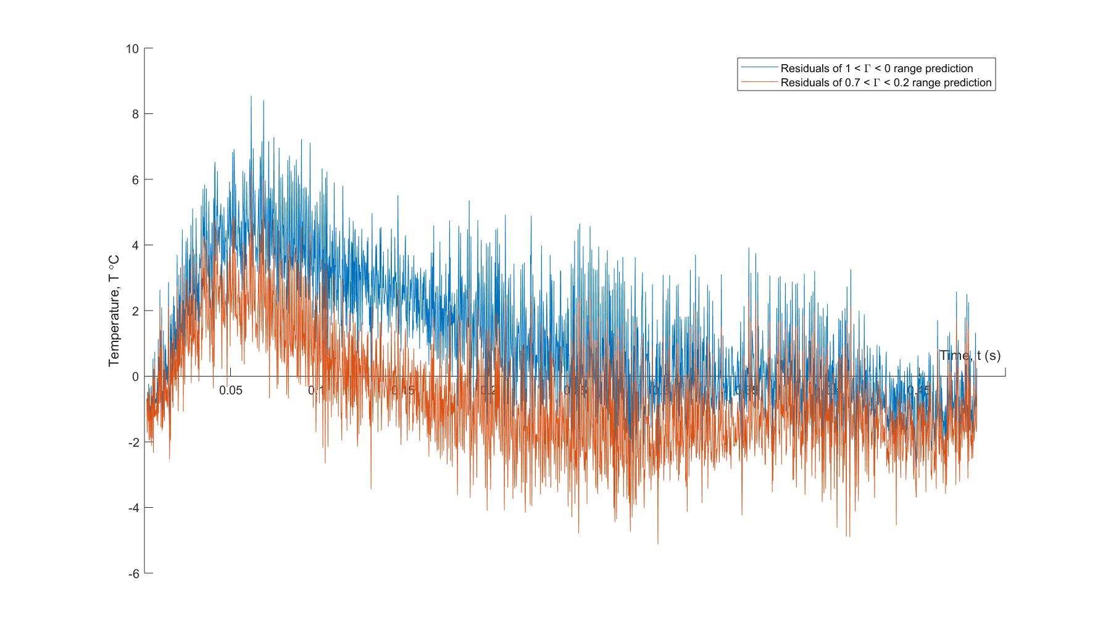

Figure 11 - The residuals of the bare thermocouple transition from ice water to boiling water comparing the accuracy of the two different Gamma fits. Notice how the 0.2 to 0.7 Gamma fit is far more accurate during the beginning of the test.

A close up of a device

Description generated with high confidence

Figure 12 - The residuals of the steel-insulated thermocouple transition from ice water to boiling water comparing the accuracy of the two different Gamma fits. Notice how the 0.2 to 0.7 Gamma fit is far more accurate during the beginning of the test.

|  |  |  |  |  |
| --- | --- | --- | --- | --- |
| Type of Thermocouple | Environmental Transition | Γ range | , Second | Syx,  ͦC |
| Bare | Ice to Boil | 1<Γ<0 | 0.1412 | 2.1746 |
| Bare | Ice to Boil | 0.7<Γ<0.2 | 0.1275 | 1.5633 |
| Bare | Boil to Ice | 1<Γ<0 | 0.1389 | 1.8505 |
| Bare | Boil to Ice | 0.7<Γ<0.2 | 0.1245 | 1.4436 |
| Steel | Ice to Boil | 1<Γ<0 | 2.889 | 2.4622 |
| Steel | Ice to Boil | 0.7<Γ<0.2 | 3.2287 | 1.5 |
| Steel | Boil to Ice | 1<Γ<0 | 8.5699 | 4.5217 |
| Steel | Boil to Ice | 0.7<Γ<0.2 | 6.2679 | 2.8158 |
| Aluminum | Ice to Boil | 1<Γ<0 | 5.3246 | 2.2625 |
| Aluminum | Ice to Boil | 0.7<Γ<0.2 | 6.0426 | 1.4729 |
| Aluminum | Boil to Ice | 1<Γ<0 | 7.6224 | 2.2625 |
| Aluminum | Boil to Ice | 0.7<Γ<0.2 | 6.4141 | 1.4729 |

Figure 13 – Table of primary parameters of our thermocouple with the analysis of using different Gamma fits

The fit range for Γ makes a positive difference on an accuracy of constants (lower 𝛕 and). However, none of the differences is bigger than residuals of predicted temperatures. Which leads us to a conclusion that the difference is not significant.

In theory, the time constant should be independent of the temperature transition. From our observation, we can state that the time constant for embedded thermocouples in steel and aluminum are depended of the temperature transition from ice-to-boil. We observed a larger time constant for a thermocouple going from boil-to-ice then vice versa. From our experience, this is completely due to the natural phenomena that is boiling. A major difference in the two temperature baths is the movement of the molecules at these states. When a thermocouple enters a boiling bath, the movement of the water is far greater than that of ice, causing more heat transfer to the components inside. The opposite is true for an ice water bath; the movement of the fluid is nearly still relative to the thermocouple.

Overall the lumped capacitance model with 0.7 < Γ < 0.2 range produced more accurate predictions of the time constant for a bare thermocouple and a lower standard error of the fit estimate for bare and embedded thermocouples. From our results, we observed the ratio of time constants for the stainless steel and aluminum under equivalent heat transfer conditions (boiling water to ice water) is 1.1243, does not agree with predicted ratio - 1.5847, which was found by using following ratio of equations:

where ρ of stainless steel is 8055, ρ of aluminum is 2702 , and constant heat transfer for stainless steel and aluminum is 480 J/kg*K and 903 J/kg*K, respectively (Figlioloa p.570 and 571, Table B.2).

# Summary and Conclusions

The confidence limit for bare and stainless-steel thermocouples temperature measurements is 1.8011 ℃ and 4.3418℃ respectively (1<Γ<0 range) and 1.8458℃ and 4.3733℃ (0.7<Γ<0.2 range)

Restricted fit range resulted in significantly lower standard error of the fit by 28.11% for bare thermocouple and by 39.07% for stainless-steel thermocouple.

The lumped capacitance model measurement does not describe the trend in material properties for the two embedded thermocouples in similar hear transfer conditions. An additional experiment will be needed to determine a better trend approximation for the time constant ratio.

Overall, the proposed gamma fit of 0.7<Γ<0.2 proved to be a more accurate method of prediction of the behavior of our thermocouples during the transition between two different steady-state temperature baths. Figure 16 within the appendix shows a clear distinction between when Gamma displays higher error near zero and one. Therefore, a fit using Gamma between 0.2 and 0.7 allows for an accurate fit, and a more precise time constant calculation. Appendix

|  |  |  |
| --- | --- | --- |
| Temperature,  ͦC | Thermocouple voltage, V | Thermistor, Ω |
| 0 | 0.0375 | 27200 |
| 20 | 0.2317 | 12190 |
| 30 | 0.3285 | 8160 |
| 40 | 0.4321 | 5650 |
| 50 | 0.5387 | 3940 |
| 60 | 0.6416 | 2890 |
| 70 | 0.7441 | 2160 |
| 80 | 0.8171 | 1720 |
| 90 | 0.9484 | 1340 |
| 100 | 1.02 | 1160 |

Table 2 – Table of the static calibration data of a bare thermocouple with respect to a thermistor

A screenshot of a cell phone

Description generated with very high confidence

Figure 14 - Calibration curve using the thermistor temperature and voltage of the thermocouple

A close up of a map

Description generated with very high confidence

Figure 15 - Confidence limits of the calibration curve to illustrate a 95% confidence based on the actual data and the fit

A screenshot of a cell phone

Description generated with very high confidence

Figure 16 - A confidence interval graph comparing both Gamma ranges for a bare thermocouple going from ice water to boiling water

A close up of a map

Description generated with high confidence

Figure 17 - A confidence interval graph comparing both Gamma ranges for a steel-insulated thermocouple going from ice water to boiling water

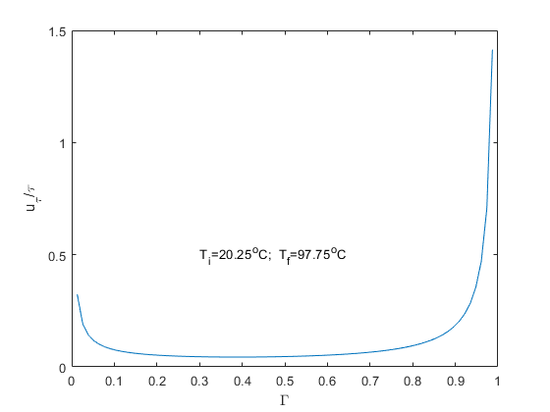

Figure 18 - The fractional uncertainty of the determination of the time constant plotted against calculated Gamma values. Notice the uncertainty near 0 and 1, inspiring the new Gamma fit using 0.2-0.7.